Quarterly Sales Flyer
1st Quarter 2024
7037 St. Rt. 327 Wellston, OH 45692

Covered Wagon Sliced Bacon 15lb. box
This bacon is a lesser quality bacon geared towards buffets.
Covered Wagon Bacon 15lb.
$34.99
$2.33/lb.
Sold in full boxes only

________________________________________________________________
Wright Brand Sliced Bacon 15lb. box
Wright Brand Bacon 15lb.
$59.99
$3.99/lb.
Sold in full boxes only

________________________________________________________________
Gerber Boneless/Skinless Chicken Breast Tray Packs
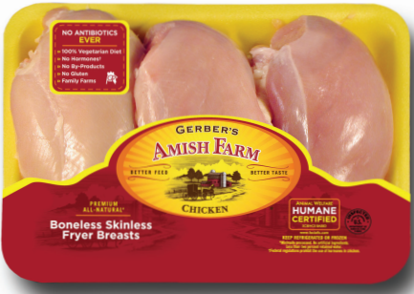
#5829
Gerber Boneless/Skinless Chicken Breasts
approx. 1 to 1-1/4 lb. per tray, 20 trays/case Approx. $89.00 $3.69/lb.
Price for full boxes only, see order form for 5 tray price.

________________________________________________________________
Gerber Leg Quarters 40lb. box
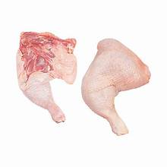
More items and order form on back
Gerber Leg Quarters 40lb.
$39.60
$.99/lb.
Sold in full boxes only

Gerber Breast Pieces 20lb. box
Gerber Breast Pieces 20lb.
$53.80
$2.69/lb.
Sold in full boxes only

________________________________________________________________
Frozen, Uncooked Hamburger Patties
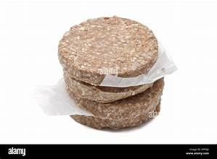
Frozen Uncooked Hamburger Patties 10lb.
$49.99
$4.99/lb.
Sold in full boxes only

Cut below and mail to Homestead or call (740) 384-3326 ext. 1
---------------------------------------------------------------------------------------------------------------------
Order Due Friday, 2/9 at 9 am.
*Notice: Since most items are sold by the pound, actual price may vary slightly.
Description | Order Qty | Price Each | *Total  Price
Covered Wagon Brand Bacon 15lb. |  | $34.99
Wright Brand Bacon 15lb. |  | $59.99
Gerber Bnlss/Sknlss Chicken Breasts (20 trays)  (5 Trays, approx. 6 lb. $3.99/lb.) | _____ | $88.56  $23.94 | ________
Gerber Leg Quarters 40lb. |  | $39.60
Gerber Breast Pieces 20lb. |  | $53.80
Hamburger Patties ¼ lb. burgers (10 lb. box) |  | $49.99
Please fill out below and send to Homestead (chris@homesteadcountrymarket.com)
or drop off at the store.
Name:_______________________________ Phone(optional) (___) ____-________
Address:_____________________________ City_________________ Zip_________

Please pick up items on Thursday 2/15 to Saturday 2/17

